Out app uses 2 types of global control flows.

For the server part we use Thread-based control since all the operations need to be non blocking.

Since we use a REST service all the concurrency control is done.

Concurrency is the control of the number of threads active in an InstanceContext at any one time.

This is controlled by using theServiceBehaviorAttribute.ConcurrencyMode with the ConcurrencyMode enumeration.

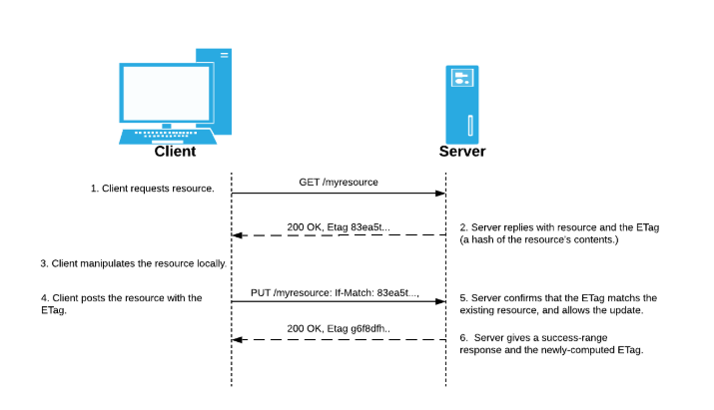

For the UI part we use Event-driven control since all the windows need to be updated in real time and should not wait for the data to be updated in the database.

The User should be allowed to still use the app even though the server was not yet updated with the new data.

For this we can use the Observer Design Pattern.

